**Angkatan Pelukis Se-Malaysia**

Angkatan Pelukis Se-Malaysia (APS)(All Malaysian Painters’ Front) is recognised as one of the first Malay art collectives in Malaysia. It functions as both a social club as well as a promoter of realism as a painterly style, specifically amongst the Malay community. This was a radical development in its time, given that traditional Islamic Malay society had a culturally strong proscription against the depiction of the human figure. To this end, it was active in holding exhibitions and art classes for members and art enthusiasts in post-war Kuala Lumpur. The society originated in the Malay Arts Council which was established in 1956 at the United Malay National Organisation (UMNO) political party’s headquarters in Kuala Lumpur. The founding of APS is connected to the migration of Java-born painter Hoessein Enas to Malaya in 1948 during the Indonesian revolution. He would soon gain repute as highly skilled portrait painter and would become the Malay Arts Council’s first chairman. The impetus in the creation of the APS was inspired in part by the organisation that Hoessein Enas co-founded in Medan in 1944 called Angkatan Seni Rupa Indonesia, not be confused with Akademi Seni Rupa Indonesia, which is the art school established in Yogyakarta in 1950.

Hoessein’s connection to Indonesian art discourse along with the growth of Malay nationalism, including the establishment of the literary movement ASAS 50, inspired the founding of an organisation that hoped to foster a Malayan and later Malaysian art centered on the concept of ‘art for society’. Originally the organisation promoted painting, music, acting, dance and literature, with most of the activities held in the back room at Hoessein Ennas’s home, known as the ‘Club House’. As it became clear that painting predominated as the main activity of the organisation, the group voted to change its name to Angkatan Pelukis Semenanjung in 1958. The organisation became so closely linked to Malay nationalist causes that it soon found a patron in Tunku Abdul Rahman Putra Al-Haj, the first prime minister of Malaya and later Malaysia.

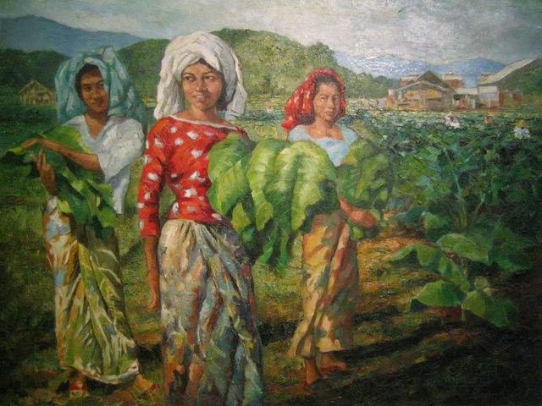

Mohammad Hoessein Enas, *Memetik Daun Tambakau Di Kelantan* (*Harvesting Tobacco in Kelantan*), 1962, oil on canvas, National Visual Art Gallery of Malaysia.

With the formation of Malaysia in 1963, the name was once again changed, this time to Angkatan Pelukis Se-Malaysia in 1968. Hoessein Enas stepped down as president in 1964, to be succeeded by Mazeli Mat Som. Under Mazeli’s leadership, the organisation expanded to include branch organisations in other states such as Kedah, Pahang, Sabah and Sarawak. There was also renewed effort to foster international exchange with artists from Singapore, Indonesia and India. More importantly, it hosted a number of Indonesian artists on their trips to Kuala Lumpur including Affandi, Basuki Abdullah, Sudarso, Srihadi, Kartika Affandi, etc. On top of this, the society also organized to undertake trips to Singapore and Indonesia.

By the 1960s, activities shifted to a two-storey building rented from the Malay Teacher’s Association of Selangor. Sabtu Yusof, who graduated from a German art school, was appointed as resident artist and ground manager. It was at this site where they held painting classes on Saturdays that were equally popular amongst expatriates and local art enthusiasts. The building also had a gallery space to showcase works by artists working in Kuala Lumpur, which was christened *Dewan Seni Rupa* (Fine Arts Hall). It was perhaps because of this close connection with Indonesia that the Indonesian term seni rupa was introduced to mean visual arts in Malaysia as well.

This also meant the production of a semantic field that was regional and localised, leading to some inevitable conflict between artists who were trained in the West and artists who were self taught and trained locally through the APS art classes. This came to a clash in 1968 where members of APS initiated the walk out from the 1968 Salon Malaysia art exhibition to protest against the competition, which they felt was partial towards abstraction and prejudicial towards realism. With Hoessein Enas withdrawing his work from the exhibition, a large number of APS members soon follow suit.

Yet a survey of output by APS member from that period shows that they were not entirely anti-abstraction, in spite of the organisation’s inclination towards realism. After all, Syed Ahmad Jamal, who took over from Mazeli as chairman in 1970, is an abstract painter. A likelier explanation can be gleamed from their participation in the 1971 debate at the National Cultural Congress. The debate revolved around the direction that art should take, and a vote between ‘art for society’ versus ‘art for art’s sake’ was taken. APS members who were largely Malay art teachers overwhelmed those who supported the latter position. This was rooted in their belief in the ideals of the literary movement, ASAS’50.

As such, what the APS was opposed to was what they perceived to be a blind aping of ‘Western ways’. A future reading of how class struggle played out in this episode of Malaysian art history could perhaps more succinctly reveal the causes of such conflict. In short, a divergence of ideals drove a wedge between those who were trained in England and America, who favoured the notion of ‘art for art’s sake’ compared to a locally trained group of artists who held on to the spirit of art requiring to serve society that was rooted in a more regional context and was connected to the Indonesian revolutionary movement, ideas that were brought over to Malaysia by Hoessein Ennas.

However, APS’s victory at the National Cultural Congress was short lived. By the mid 1970s, the tides were turning against them, with mismanagement leading to its deregistration in 1974. This emboldened a younger group of artists from APS to set out on their own to establish the Anak Alam art collective the same year. APS sputtered back into existence in 1975 but never regained its prominence. As Mazeli returned to the helm of the revived organisation, he also set the tone for what APS would eventually be known primarily as: an art organisation that favoured figurative and naturalistic style of painting.

**References and Further Reading**

----- (1999) *The Life and Art of Hoessein Enas*, Penang: The Art Gallery Penang.

Abdullah, Sarena. ‘Absenteeism of Malaysian Identity in Art in the Early Years of Independence’, *Jati: Journal of Southeast Asian Studies*, Volume 15 Issue 1, 2010.

Sabapathy, T.K. (1994) ‘ Merdeka Makes Art, or Does It?’, *Vision and Idea: Relooking Modern Malaysian Art*, Kuala Lumpur: National Art Gallery, 71.

Wharton, Dolores. (1971) *Contemporary Artists of Malaysia. A Biographical Survey*, Petaling Jaya: Asia Society and Union Cultural Organisation, 99-101.

Zainol Abidin Ahmad Sharif. (1998) *Meeting Modernity: Forty Years of the APS Malaysian Artists Movement 1956 – 1996*, Kuala Lumpur: Balai Seni Lukis Negara.